Data structures

Name: Fajar Khalil
Sap id: 68935

Task 1
Declare an array of 5 integers, use a pointer to iterate through it, and print each element.
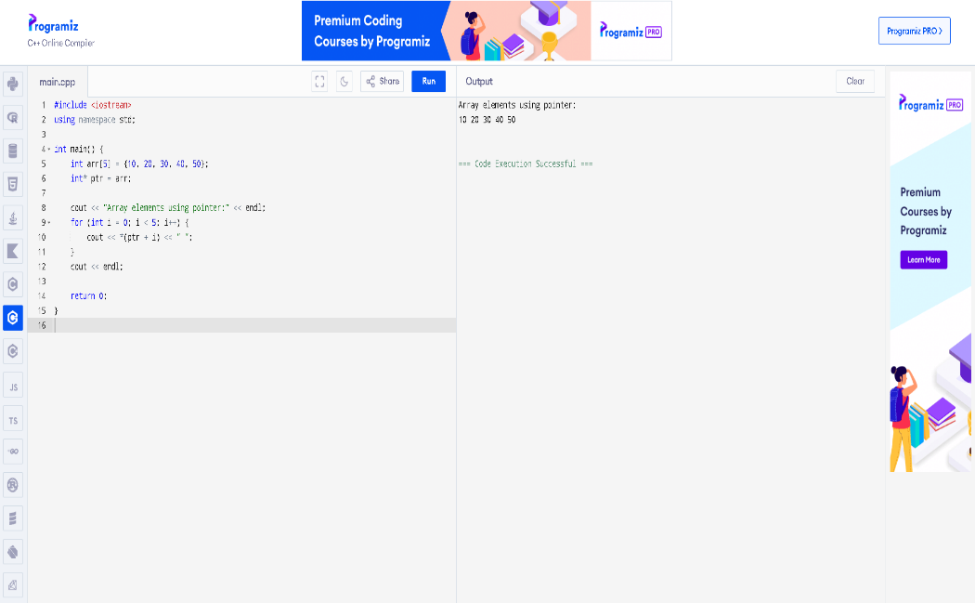

Task 2
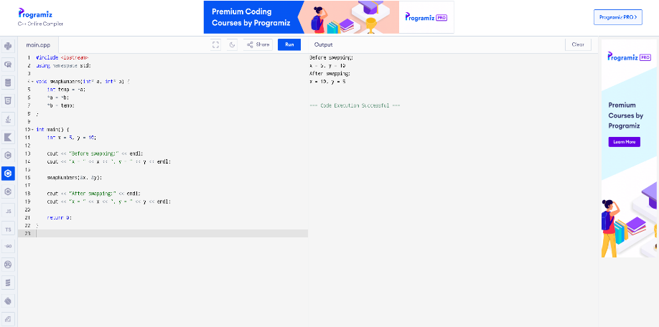
Define a function that swaps two integers using pointers and demonstrate it in main ().

